1. Importing Data into Power BI

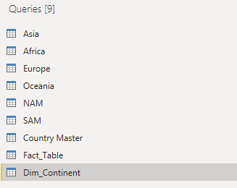

* I have removed nulls and duplicate rows from the **Country Master table**

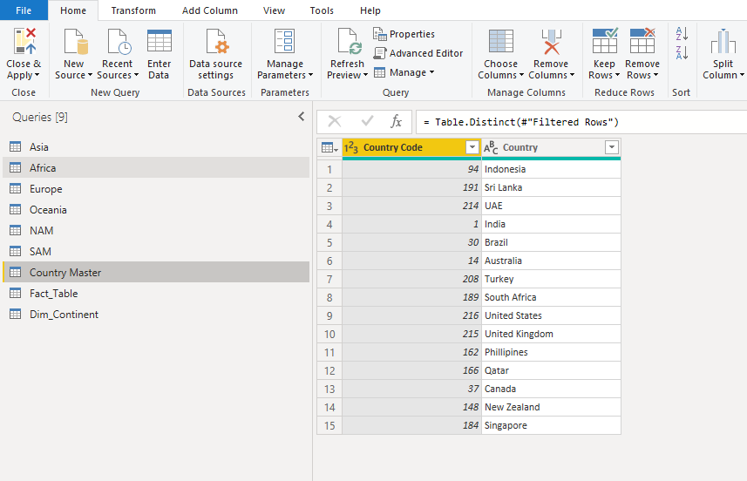

1. Appended the table into one Dim_Table

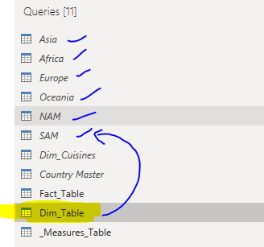

3. Merging

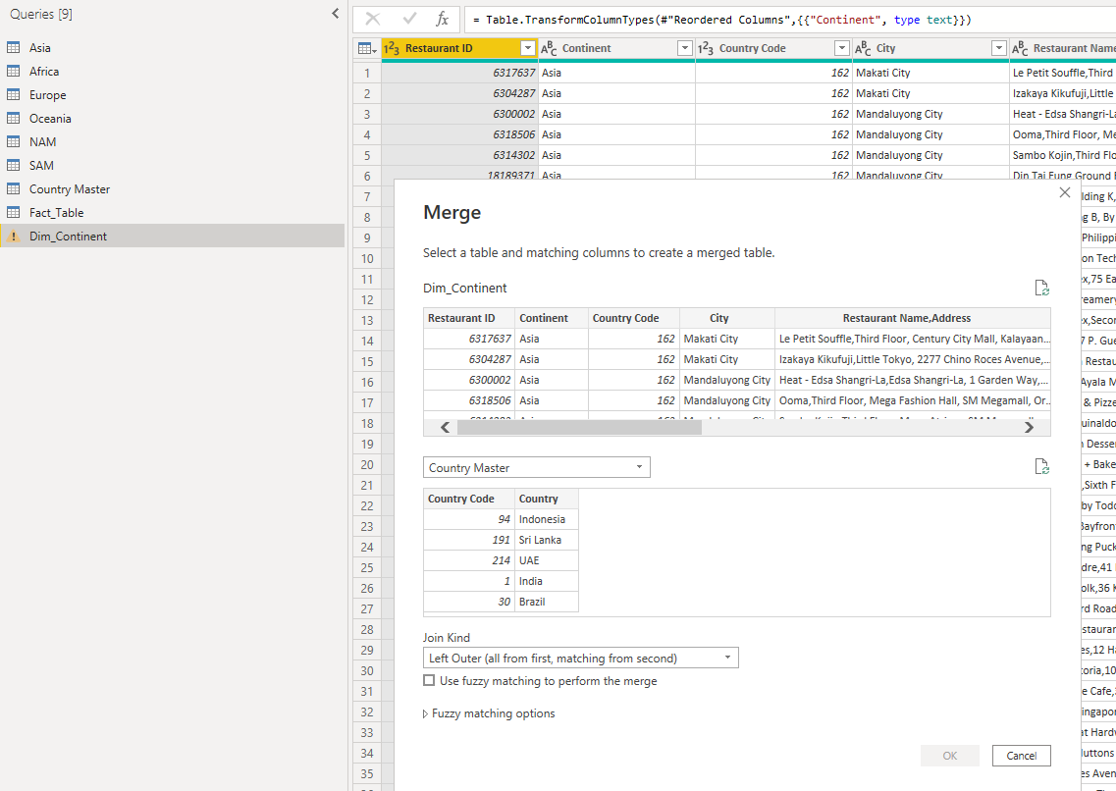

4. Create two columns to display the **Restaurant Name** and **Restaurant Address**

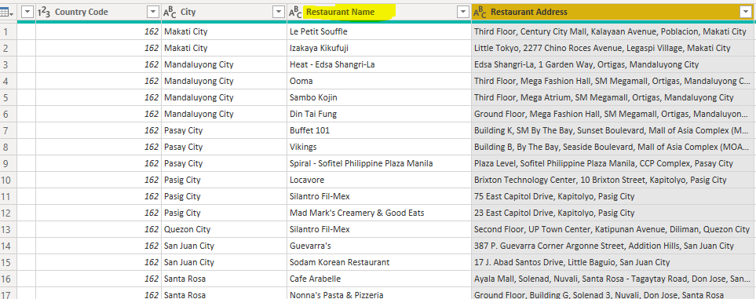

5. Make a separate table for the list of the cuisines that each restaurant serves

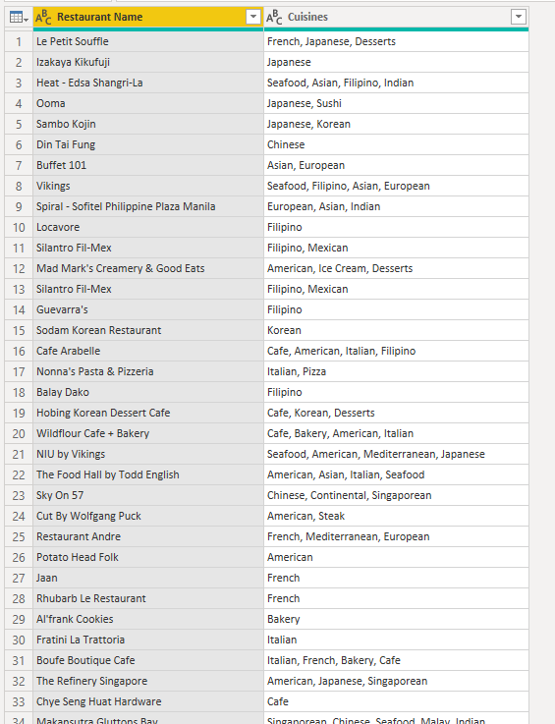

6. As it's a dimension table, the **Country-Code** table must only include unique and non-blank values

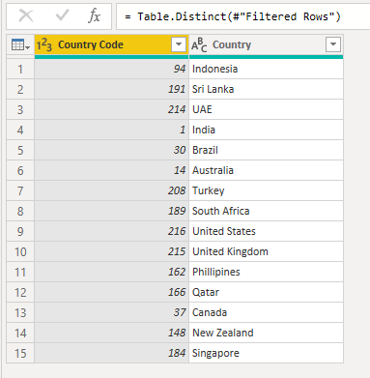

1) Add a **Rating color** column in an appropriate table with the data rows in the format given below

|  |  |
| --- | --- |
| **Aggregate rating** | **Rating color** |
| Above 4.5 | Dark Green |
| 4 to 4.4 | Green |

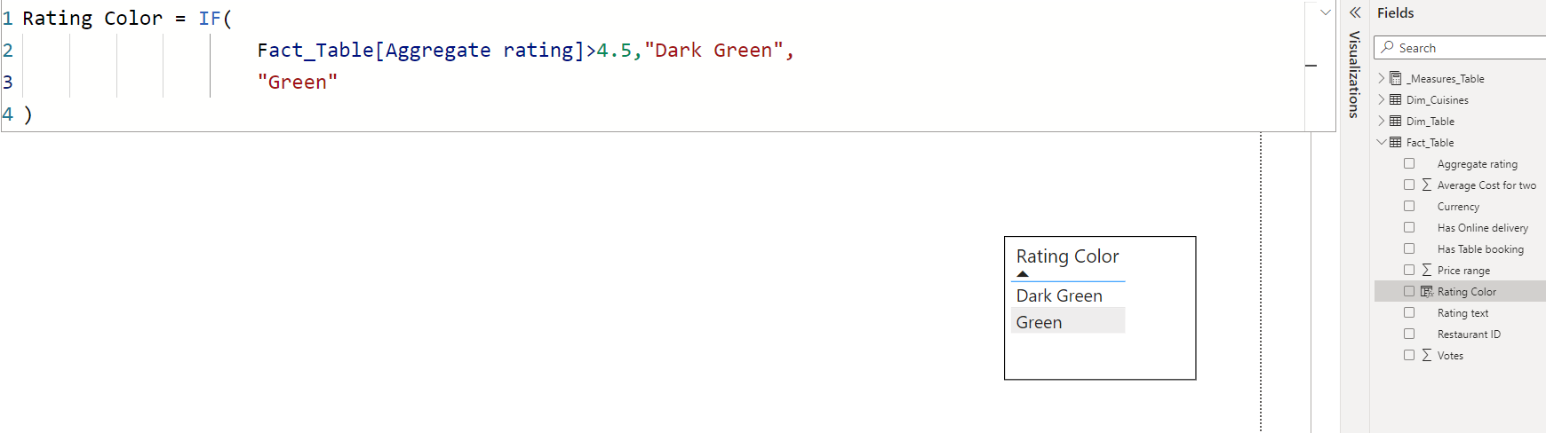

2) Create the following measures in the appropriate tables

a. Restaurant count

b. Average cost

c. Average rating

d. Cuisine count

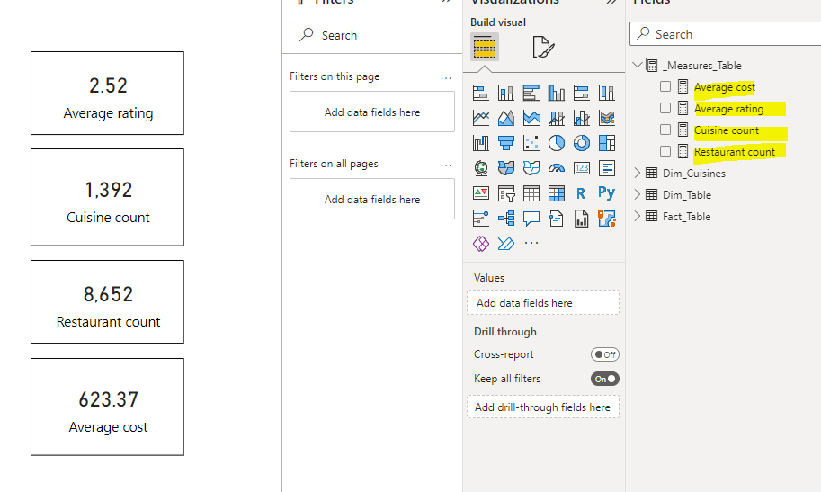

3) Create a new column in the **Country Code** table and name it “**Continent”** and create the values using the below-mentioned convention

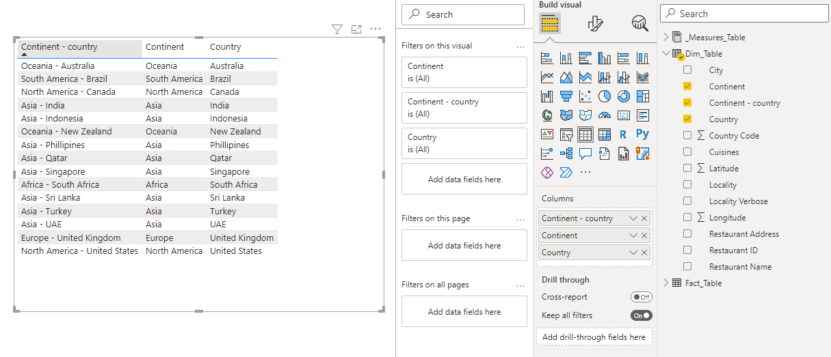

Here is the final Output on the report:

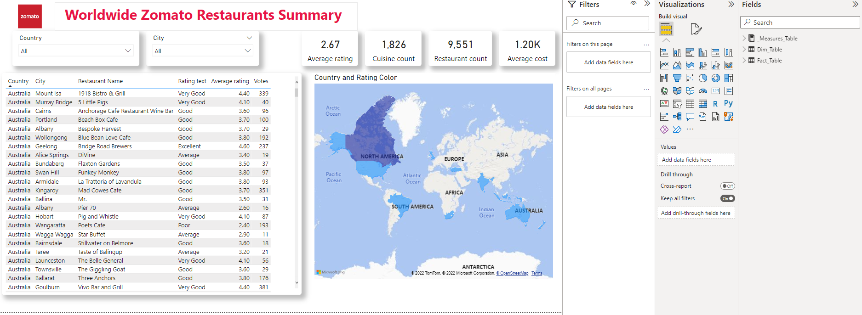

**Filtering data to India:**

